Developments in dementia care in the Netherlands since the mid nineties

A new concept in dementia elderly care, living in lifestyles.

A mirror image of recognizable lifestyles in our society.

- 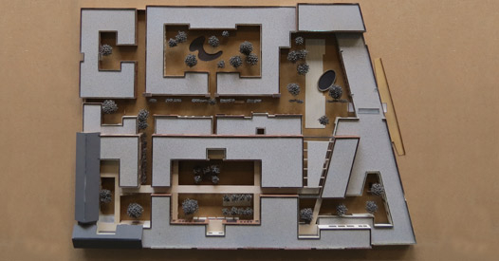
overview total units
- 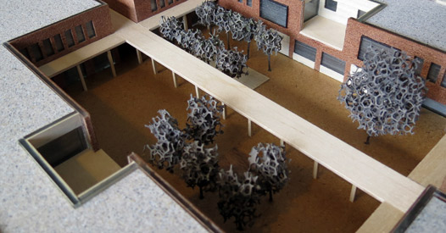
the main square
- 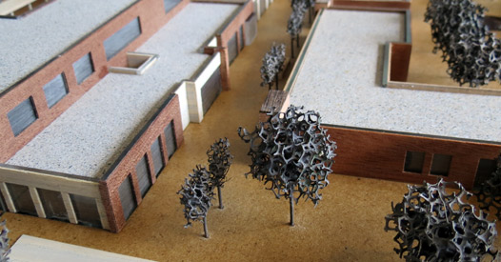
BOULEVARD/THEATER square
- 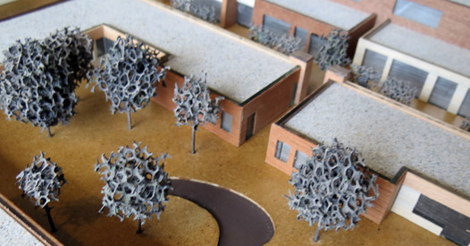
pond PARK
- 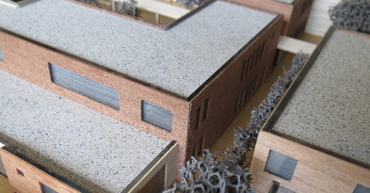
LINDELAAN
- 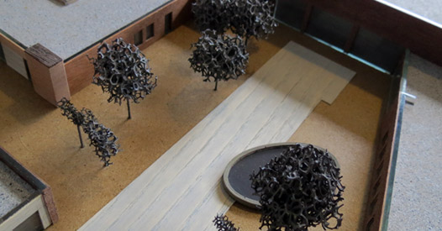
THEATER PARK
- 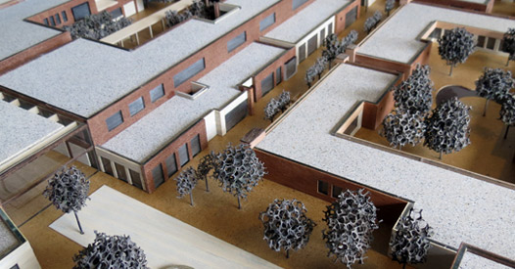
THEATER PARK/BOULEVARD
- 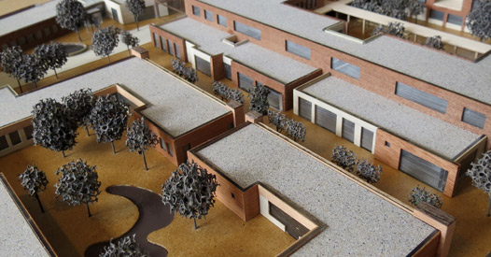
pond PARK/BOULEVARD
- 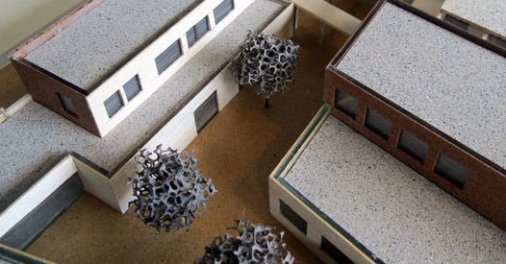
east corner

This concept is based on a weyk/wijk principle as care centre. A weyk or wijk being a group of houses, similar to a village) is a specially designed village with 23 houses for 152 dementia-suffering seniors. The elderly all need nursing home facilities and live in houses differentiated by lifestyle. This idea offers 7 different lifestyles: urban, artisan, country based lifestyle, homey, upper class, cultural and religious based lifestyle. The residents manage their own households together with a constant team of staff members. Washing, cooking and so on is done every day in all of the houses. Daily groceries are done in the supermarket . This concept offers its dementia-suffering inhabitants maximum privacy and autonomy. The village has streets, squares, gardens and a park where the residents can safely roam free. Just like any other village this concept offers a selection of facilities, like a restaurant, a bar and a theatre. These facilities can be used by the residents AND residents of the surrounding neighbourhoods. Everybody is welcome to come in!

New view on Dementia care

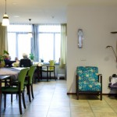
Country based life style: Indonesian living room

Country based life style
This view on care is founded in day to day life in society. In normal society living means having your own space to live and managing your own household. People live together with other people sharing the same ideas and values in life. This makes the place where one lives a home.
The residents have already lived a life where they shaped their own life, where they made choices about their own household and standards. The fact that a resident cannot function “normally” in certain areas, being handicapped by dementia, does not mean that they no longer have a valid opinion on their day to day life and surroundings. The residents opinion on life, housing, values and standards determine their “lifestyle”. There are 7 lifestyles defined in this concept: urban, artisan, country based lifestyle, homey, upper class, cultural and religious based lifestyle. Every home houses six to eight people with the same lifestyle. This lifestyle can be seen in the decor and layout of the house, the interaction in the group and with the members of staff, day to day activity and the way these activities are carried out. Every house manages its own household with a permanent staff. Another aspect of normal living is being able to move freely inside the house AND outside. A normal house in a normal village in a safe environment gives the residents in this concept a big freedom in safety.
Introduction
The concept of Snoezelen/Multi-Sensory Environment (MSE) in several research studies has shown the positive effectiveness of the method with patients who have dementia.
From recent study, Snoezelen/Multi-Sensory Environment has proven to be effective in decreasing the amount of disruptive and aggressive behaviours among individuals with Alzheimer’s disease. With a decrease in such disruptive behaviours and a reduction of medications. The caregivers will be more able to appropriately care for their loved ones at home and within the community. In conclusion these results point out that Snoezelen/Multi-Sensory Environment has also positive effects on the quality or working life of staff members in psychogeriatric care.

Snoezelen in Dementia care in the Netherlands.
The concept of Snoezelen/Multi-Sensory Environment (MSE) was developed in the Netherlands in the 1970s and was first introduced to people with learning difficulties.
Since the beginning of the 1990s, the MSE has been used as a nonpharmacological therapy for people with dementia. The multisensory stimulation typically occurs in a specifically designed room known as a Snoezelen or multisensory stimulation room (MSSR). This room includes many objects that pertain to the 5 senses, including fibre-optic cables, water columns, aroma therapy, different music/sounds, tactile objects, and screen projectors among others.
Elderly people with dementia, particularly those who are institutionalized, are exposed to either sensory deprivation or excessive sensory stimulation. The imbalances in the pacing of sensory-stimulation or sensory-calming activity affect the behaviour and the instrumental and social function of institutionalized people with dementia.

One of the distinguishing elements of Snoezelen/MSE compared to other therapies is the one-to-one attention and the adoption of a nondirective approach, which encourages patients to engage with sensory stimuli of their choice.
Because Snoezelen/MSE does not appeal to cognitive abilities, it is one of the few approaches that are suitable for persons with severe or very severe dementia and limited verbal communication capabilities. Nonpharmacological interventions are recommended as first-line therapies for patients with these characteristics due to the safety concerns related to pharmacologic therapies.

The intervention study investigate whether Snoezelen/MSE, applied by the care workers and integrated in 24-h daily care, leads to a positive change in mood and behaviour of demented nursing home residents as compared to residents receiving usual care, i.e., without Snoezelen/MSE.
In particular, the intervention lead to measurable, positive changes in
- well-being: more happiness/contentment, more enjoyment, better mood;
- adaptive behaviour: more attentive and responding to environment, more own initiatives,
- better relationship to care worker;
- maladaptive behaviour: less non-social behaviour, apathetic behaviour, loss of decorum, loss of consciousness, rebellious behaviour, restless behaviour,
- disoriented behaviour, anxiety, aggression, agitation and depression.

The intervention study examine the effects of the implementation of Snoezelen/MSE on the non-verbal and verbal communication of the care workers and residents during the daily care. In particular, it lead to the following measurable changes:
- an increase of non-verbal communication of both care workers and residents (e.g., gazing, affective touch, smiling);
- an increase of the affective or socio-emotional verbal communication of care workers that is needed to establish a trusting relationship (e.g., showing empathy, social talk, validation);
- a decrease of negative affective verbal communication of both care workers and residents (e.g., showing disapproval or anger);
- a decrease of negative instrumental communication, initiated by care workers (e.g., questions about facts, cognitive knowledge).

However, the provision of a generally stimulating and comfortable environment does not necessarily eliminate the potential need for a specific multi-sensory space - whether it is a semi-open area or corner embedded in the general living environment or a multi-sensory room where it is possible to close the door for focused activities and sensory sessions.

Where possible a multi-sensory space should always be accessible to residents at any time - whether it is a room (door should be open or unlocked) or a sensory area. This ensures that residents can use the space on their own whenever they want to, giving them choice and control. It also makes for a more cost effective approach which does not rely on staff having to take the residents to the space.

The room/area should be set up in such a way that it is safe for the residents to access if unsupervised. Potentially harmful items or expensive equipment should be stored/locked away or secured in such a way that it cannot be dismantled or broken by the residents.
Ideally the room/space should be located near the lounge where care workers can easily support the residents using the multi-sensory space.

