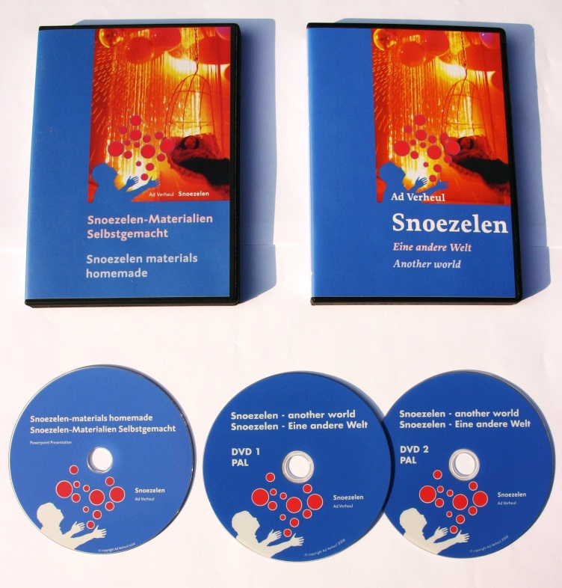

2 DVD: Snoezelen - another world, 180 min., voice-over in German language and subtitle in English language. PAL system
- Snoezelen – another world
- A virtual tour around the Snoezelen Complex of the Centre De Hartenberg
- Snoezelen in everyday practice
- Snoezelen – a new approach for people with senile dementia
- The swimming pool as a Snoezelen-room
- Snoezelen in a special Riding School
1 CD-ROM: Snoezelen materials homemade
- Do it yourself ideas how to build Snoezelen equipment. Digital edition of the book: “Snoezelen materials homemade” (224 pages including building drawings and full colour photos of the equipment’s

PowerPoint presentations:
- full colour prints of all the Snoezelen equipment.
a virtual tour around the Snoezelen Centre of De Hartenberg, including numerous photographs and floor plans
a virtual tour around the compound of the Hartenberg Centre.
Snoezelen materials homemade, construction manuals, tips and practice related information.
Snoezelen with people with dementia, a virtual tour around a nursery home
Snoezelen in nature, information on how to create a sensory garden
Snoezelen alternatives: Snoezelen in a special Riding School, Snoezelen in the swimming pool

Price: € 15,00 ( without shipping costs)

Index of the book
Fundamental philosophy of Snoezelen- historical background, planning and concept
History of the care of the mentally handicapped in the Netherlands
The development of Snoezelen
The centre De Hartenberg
Neurological bases
The Snoezelen-rooms in the centre De Hartenberg
Practice in the Snoezelen-rooms in the centre De Hartenberg in Ede, the Netherlands
Snoezelen materials homemade
Snoezelen in everyday practice
A Snoezelen-room in the residential setting
A central Snoezelen-room outside the residential setting
A tactile room; tactile stimulation
An aural room: audible stimulation
A visual room, visual stimulation
Olfactory stimulation
The swimming pool as a Snoezelen-room
The sensory garden
Music and its applications within snoezelen
Bibliography and music list
Snoezelen-materials /suppliers of Snoezelen equipments
Snoezelen in professional training

